**13 october Assignment:**

1. **Do’s and dont with the box model.**

**Do's:**

* **Use CSS to control box model properties: CSS (Cascading Style Sheets) is the primary tool for controlling the box model. Use properties like padding, border, and margin to adjust the dimensions of elements.**
* **Use consistent units: Use consistent units like pixels (px), percentages (%), or ems for specifying dimensions. This helps maintain a consistent layout and improves responsiveness.**
* **Add padding for space: Use the padding property to create space between the content and the border. This can improve readability and make the design more visually appealing.**
* **Style borders: Utilize the border property to add decorative borders to elements. You can control border width, style, and color to achieve various visual effects.**
* **Use margin for spacing between elements: The margin property is used to control the space between elements. It's useful for creating spacing between different elements on a page.**

**Don'ts:**

* **Neglect box-sizing: By default, elements use the "content-box" value for the box-sizing property, which doesn't include padding and borders in an element's width. It's often better to use the "border-box" value to include padding and border widths in the specified element's dimensions.**
* **Use negative values excessively: While negative margins and padding can be used creatively, overuse can lead to unpredictable layout issues. Be cautious when employing negative values.**
* **Don't forget to clear floats: When you use floated elements, make sure to use techniques like clearfix to ensure that containers expand to contain the floated elements correctly.**
* **Avoid overuse of margin for spacing: While margins are handy for creating space between elements, excessive margin usage can lead to layout issues and make your design less maintainable.**
* **Don't use fixed widths for responsive designs: Avoid specifying fixed widths for elements that need to adapt to various screen sizes. Instead, use relative units like percentages or ems to create responsive designs.**
* **Be mindful of the total width: When setting the dimensions of an element (content width + padding + border), ensure that it fits within the container without causing overflow or layout issues.**

1. **Create an Indian Flag using position HTML.**

**Index.html code:**

**<!DOCTYPE html>**

**<html lang="en">**

**<head>**

**<meta charset="UTF-8">**

**<meta name="viewport" content="width=device-width, initial-scale=1.0">**

**<link rel="stylesheet" href="styles.css">**

**<title>Indian Flag</title>**

**</head>**

**<body>**

**<div class="flag">**

**<div class="saffron-stripe"></div>**

**<div class="white-stripe">**

**<div class="chakra"></div>**

**</div>**

**<div class="green-stripe"></div>**

**</div>**

**</body>**

**</html>**

**Styles.css code:**

**body {**

**margin: 0;**

**padding: 0;**

**display: flex;**

**justify-content: center;**

**align-items: center;**

**height: 100vh;**

**background-color: #f0f0f0;**

**}**

**.flag {**

**width: 300px;**

**height: 200px;**

**display: flex;**

**flex-direction: column;**

**}**

**.saffron-stripe {**

**flex: 2;**

**background-color: #ff9933;**

**}**

**.white-stripe {**

**flex: 2;**

**background-color: #fff;**

**}**

**.green-stripe {**

**flex: 2;**

**background-color: #138808;**

**}**

**.chakra {**

**width: 50px;**

**height: 50px;**

**background-color: navy;**

**border-radius: 50%;**

**position: absolute;**

**top: 50%;**

**left: 50%;**

**transform: translate(-50%, -50%);**

**z-index: 1;**

**display: flex;**

**justify-content: center;**

**align-items: center;**

**}**

**output:**

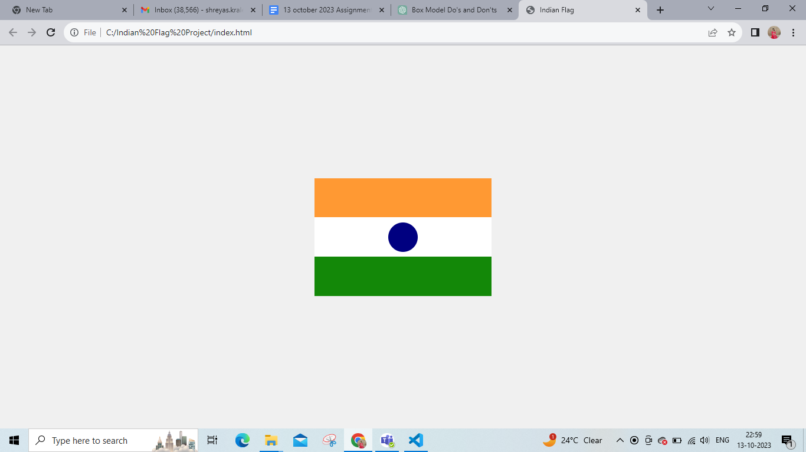

1. **Box border with top, bottom, left and right**

**Code:**

**<!DOCTYPE html>**

**<html>**

**<head>**

**<style>**

**.box {**

**width: 200px;**

**height: 100px;**

**background-color: white;**

**border-top: 5px dashed red;**

**border-bottom: 20px dashed blueviolet;**

**border-left: 15px dashed orange;**

**border-right: 10px dashed green;**

**}**

**</style>**

**</head>**

**<body>**

**<div class="box"></div>**

**</body>**

**</html>**

